# May Day Liberty Packing List

Before Leaving:

Advise Family / Police of Itinerary

Empty Perishables from Fridge

Gather Trash

Hold Mail / Put Package Sign on Door

Mail Bills / Gifts / Holiday Cards

Instructions / Key to Person Watching House

Make Bank Deposit / Get Cash

Set Timers / Lights

Turn Off A/C

Turn Off Ice Maker

Turn Off Computer / Cables / Mouse / Software

Water Plants / Open Blinds for Light

Words for Postcards / Post Card Address Labels / Stamps

For Carry On Bag:

Airline Ticket / Baggage Tags / Cruise Ticket / Cruise Passage Contract / Passport / Travel Documents / Copy of Travel Insurance

Blanket

Books

Camera / Batteries / Memory Cards / Charger

Cell Phone / Phone Numbers / Charger

Ear Plugs / Sleep Mask

Jewelry

Money / Traveler’s Checks / Credit Cards /

Excursions / Tips / Slots / Souvenirs

Reading Glasses / Contact Lenses

Rx Drugs / Excedrin / Naproxen /Aspirin / Tylenol / Airborne / Motion Sickness / Antibiotic / Rx Documentation

Snack for Trip / Emergencies

Travel Pillow

Travel Umbrella / Rain Poncho

Clothes:

Belts / Gloves / Hats / Scarves / Ties

Bras / Underwear / Slips

Dresses / Skirts – Casual / Formal / Dressy

Jackets / Coat

Pajamas / Robe / Slippers

Shirts / T-Shirts

Shoes / Boots / Snow Boots – Flip Flops /

Casual / Dress / Sneakers / Water Shoes

Shorts

Slacks / Jeans

Socks / Hose

Sweaters / Sweatshirts

Swim Suits / Beach Towel / Cover Up / Sun Hat

Toiletries:

Alcohol Wipes / Kit / Bactine Spray / Band Aids / Deep Woods Off / Suntan Lotion

Blow Dryer / Curling Iron / Clips / Hot Rollers

Hair Brush / Hair Spray

Hair Conditioner / Hair Shampoo

Kleenex / Tissue / Handkerchiefs

Lotion / Moisturizer

Makeup / Mirror

Nail Polish / Remover

Q-Tips

Razor / Shave Cream

Safety Pins / Sewing Kit

Soap

Toothbrush / Toothpaste

Miscellaneous:

Back Pack / Fanny Pack / Purses

Bed Pillow / Air Mattress / Bedding / Towels / Sleeping Bag

Binoculars

Bottled Water / Soft Drinks-6 Pack

Business Cards / Calling Cards / Insurance Card

Camp Chair

Door Decorations / Putty or Magnet or Tape

Downy Wrinkle Release / Laundry Soap

Floats / Snorkel Gear

Food - Candy / Caramels / Cheese / Cookies / White Chocolate / Crackers / Zip Bags

Groceries – Baked Goods

Hobby / Craft Project

Highlighters / Pens / Note Paper / Post It Notes / Writing Paper / Bookmarks / Playing Cards

Ice Chest

Passport Photo Copy / Birth Certificate Copy

Plastic Bags for Dirty Clothes

Power Converter Plugs

Travel Alarm

Travel Games (Cards / Scrabble / Connect 4 / Hi-Q / Dot Dot Dot / Sudoku / Crossword / Guesstures)

# May Day Liberty Packing List

|  |  |  |  |  |  |  |
| --- | --- | --- | --- | --- | --- | --- |
|  | | | | | | |
| Saturday, April 28 – Day Minus 1 – Mansfield to Galveston Pre-Cruise | | | | | | |
|  | Mansfield to Galveston | | | |  | |
| 9:30 AM √ |  | | | |  | |
| Bra/Slip | Panties | Top | Bottom | Shoes | Jewelry / Other |
| Off White | Yellow | White and Black Circles | Nylon Shorts |  |  |
| 2:00 PM | Lunch at Pho 20 Vietnamese Restaurant | | | | 2101 Broadway  Galveston, TX 77550  409-750-9200 | |
|  | | | | | | |
| Sunday, April 29 – Day 1 – Galveston | | | | | | |
|  |  | | | |  | |
| 11:00 AM √ | Board Ship | | | | Reservation - #4894900 Liberty of the Seas Group 4490364 Ocean View Cabin 7652 | |
| Bra/Slip | Panties | Top | Bottom | Shoes | Jewelry / Other |
| White Cami | Yellow | Red Sleeveless | Tan Shorts |  | Yellow Glass Multi |
|  | Distribute Items | | | | Door Tags ( ) | |
| Lanyards ( ) | |
| Name Tags ( ) | |
| Bookmarks ( ) | |
|  | Onboard credit for Bonney | | | | $50.00 spent on shore tours | |
| 6:00 PM  √ | Dinner | | | |  | |
| Bra/Slip | Panties | Top | Bottom | Shoes | Jewelry / Other |
| Navy Cami | Yellow | Red Sleeveless | Navy Slacks |  |  |
|  | | | | | | |
| Monday, April 30 – Day 2 - At Sea | | | | | | |
|  |  | | | |  | |
|  |  | | | |  | |
| √ | Swimming | | | |  | |
| Bra/Slip | Panties | Top | Bottom | Shoes | Jewelry / Other |
|  |  | Blue Print | Blue Skirt |  |  |
| 9:30 AM  √ |  | | | |  | |
| Bra/Slip | Panties | Top | Bottom | Shoes | Jewelry / Other |
| Tan Cami | Yellow | Pink T-shirt | Tan Shorts |  | Silver Multi Necklace |
| Lunch | Cover Up | | | |  | |
| Bra/Slip | Panties | Top | Bottom | Shoes | Jewelry / Other |
|  |  |  |  |  |  |
|  |  | | | |  | |
| 6:00 PM  √ | Formal Dinner #1 | | | |  | |
| Bra/Slip | Panties | Top | Bottom | Shoes | Jewelry / Other |
| Black Cami | Black | Black Sleeveless Knit Dress / Aqua Scarf | | Silver Flip Flops | Black Weave Purse / Aqua Shell Bracelet / Sea Glass Necklace |
|  | | | | | | |
| Tuesday, May 1 – Day 3 - Cozumel, Mexico | | | | | | |
| 7:00 AM | Arrive Cozumel, Mexico | | | |  | |
| 9:00 AM √ | Shore Tour - Beach Break at Playa Mia | | | | $50.00 | |
| Bra/Slip | Panties | Top | Bottom | Shoes | Jewelry / Other |
| Red Cami | Yellow | Red Cowl Sleeveless Blouse | White Shorts |  | Black and White Necklace |
| 6:00 PM | Depart Cozumel, Mexico | | | |  | |
| 6:00 PM √ | Casual Dinner – no shorts | | | |  | |
| Bra/Slip | Panties | Top | Bottom | Shoes | Jewelry / Other |
| WOff hite Cami | Yellow | Black T-shirt | Spotted Skirt / Top |  | Pink Glass Necklace |
|  | | | | | | |
| Wednesday, May 2 – Day 4 - George Town, Grand Cayman | | | | | | |
| 9:30 AM √ |  | | | |  | |
| Bra/Slip | Panties | Top | Bottom | Shoes | Jewelry / Other |
| Black Cami | Yellow | Black Sparkle Cowl Blouse | Gray Shorts |  | Yellow Glass Red Multi Necklace |
| 10:30 AM | Arrive George Town, Grand Cayman | | | |  | |
|  |  | | | |  | |
| 1:00 PM – 4:30 PM | Shore Tour – 7 Mile Beach Break | | | | $51.00 | |
| Bra/Slip | Panties | Top | Bottom | Shoes | Jewelry / Other |
|  |  | Black | Black Skirt |  |  |
| 4:00 PM | Depart George Town, Grand Cayman | | | |  | |
| 6:00 PM  √ | Casual Dinner – no shorts | | | | Meet at assigned table | |
| Bra/Slip | Panties | Top | Bottom | Shoes | Jewelry / Other |
| Black Cami | Yellow | Hot Pink Speckle Cowl Blouse | Gray Slacks |  |  |
|  | | | | | | |
| Thursday, May 3 – Day 5 – Falmouth, Jamaica | | | | | | |
| 8:00 AM | Arrive Falmouth, Jamaica | | | |  | |
| 8:30 AM | Allyce Shore Tour – A Place In the Sun | | | | $30.00 | |
| 9:30 AM √ |  | | | |  | |
| Bra/Slip | Panties | Top | Bottom | Shoes | Jewelry / Other |
| Off White Cami | Yellow | Hot Pink Cowl Blouse | Gray Shorts |  | Colorful Elephant Necklace |
| 5:00 PM | Depart Falmouth, Jamaica | | | |  | |
| 6:00 PM √ | Causal Dinner – no shorts | | | | Meet at assigned table | |
| Bra/Slip | Panties | Top | Bottom | Shoes | Jewelry / Other |
| White Cami | Yellow | Navy and White Crinkle Dress | |  | Black and White Red Glass Necklace |
|  | | | | | | |

|  |  |  |  |  |  |  |
| --- | --- | --- | --- | --- | --- | --- |
| Friday, May 4 – Day 6 – At Sea | | | | | | |
|  |  | | | |  | |
|  | Swimming – Shore Tour | | | |  | |
| Bra/Slip | Panties | Top | Bottom | Shoes | Jewelry / Other |
|  |  | Turquois Multi | Black Skirt |  |  |
| 9:30 AM  √ |  | | | |  | |
| Bra/Slip | Panties | Top | Bottom | Shoes | Jewelry / Other |
| Navy Cami | Yellow | Blue Sleeveless Cowl Blouse | White Shorts |  | Blue Paper Necklace |
| 1:30 PM | Lunch at Chops Grille | | | | $19.00 | |
| Bra/Slip | Panties | Top | Bottom | Shoes | Jewelry / Other |
| Black Cami | Yellow | Ivory Short Sleeve Blouse | Black Slacks |  | 2 Red Glass Multi Necklace |
| 6:00 PM √ | Casual Dinner, No Shorts | | | | Meet at assigned table | |
| Bra/Slip | Panties | Top | Bottom | Shoes | Jewelry / Other |
| Black Under Blouse | Yellow | Ivory Short Sleeve Blouse | Black Knit Slacks |  | 2 Red Glass Multi Necklace |
|  | | | | | | |
| Saturday, May 5 – Day 7 – At Sea | | | | | | |
|  |  | | | |  | |
| 9:30 AM  √ |  | | | |  | |
| Bra/Slip | Panties | Top | Bottom | Shoes | Jewelry / Other |
| White Cami | Yellow | Black and White Striped T-shirt | Black Shorts |  | Yellow Paper Yellow Necklace |
|  |  | | | |  | |
| 6:00 PM √ | Formal Dinner #2 | | | |  | |
| Bra/Slip | Panties | Top | Bottom | Shoes | Jewelry / Other |
| Black Cami | Yellow | Black Cowl Shirred Dress | | Black Knit Pants | Gray Elephant Scarf |
|  | | | | | | |
| Sunday, May 6 - Day 8 – Galveston to Mansfield | | | | | | |
|  |  | | | |  | |
| 9:30 AM √ | Drive home to Mansfield | | | |  | |
| Bra/Slip | Panties | Top | Bottom | Shoes | Jewelry / Other |
| Navy | Black | Red Sleeveless Blouse | Tan Shorts |  | Red Paper Necklace / Red Glass Necklace |
|  | | | | | | |

Home Answering Machine

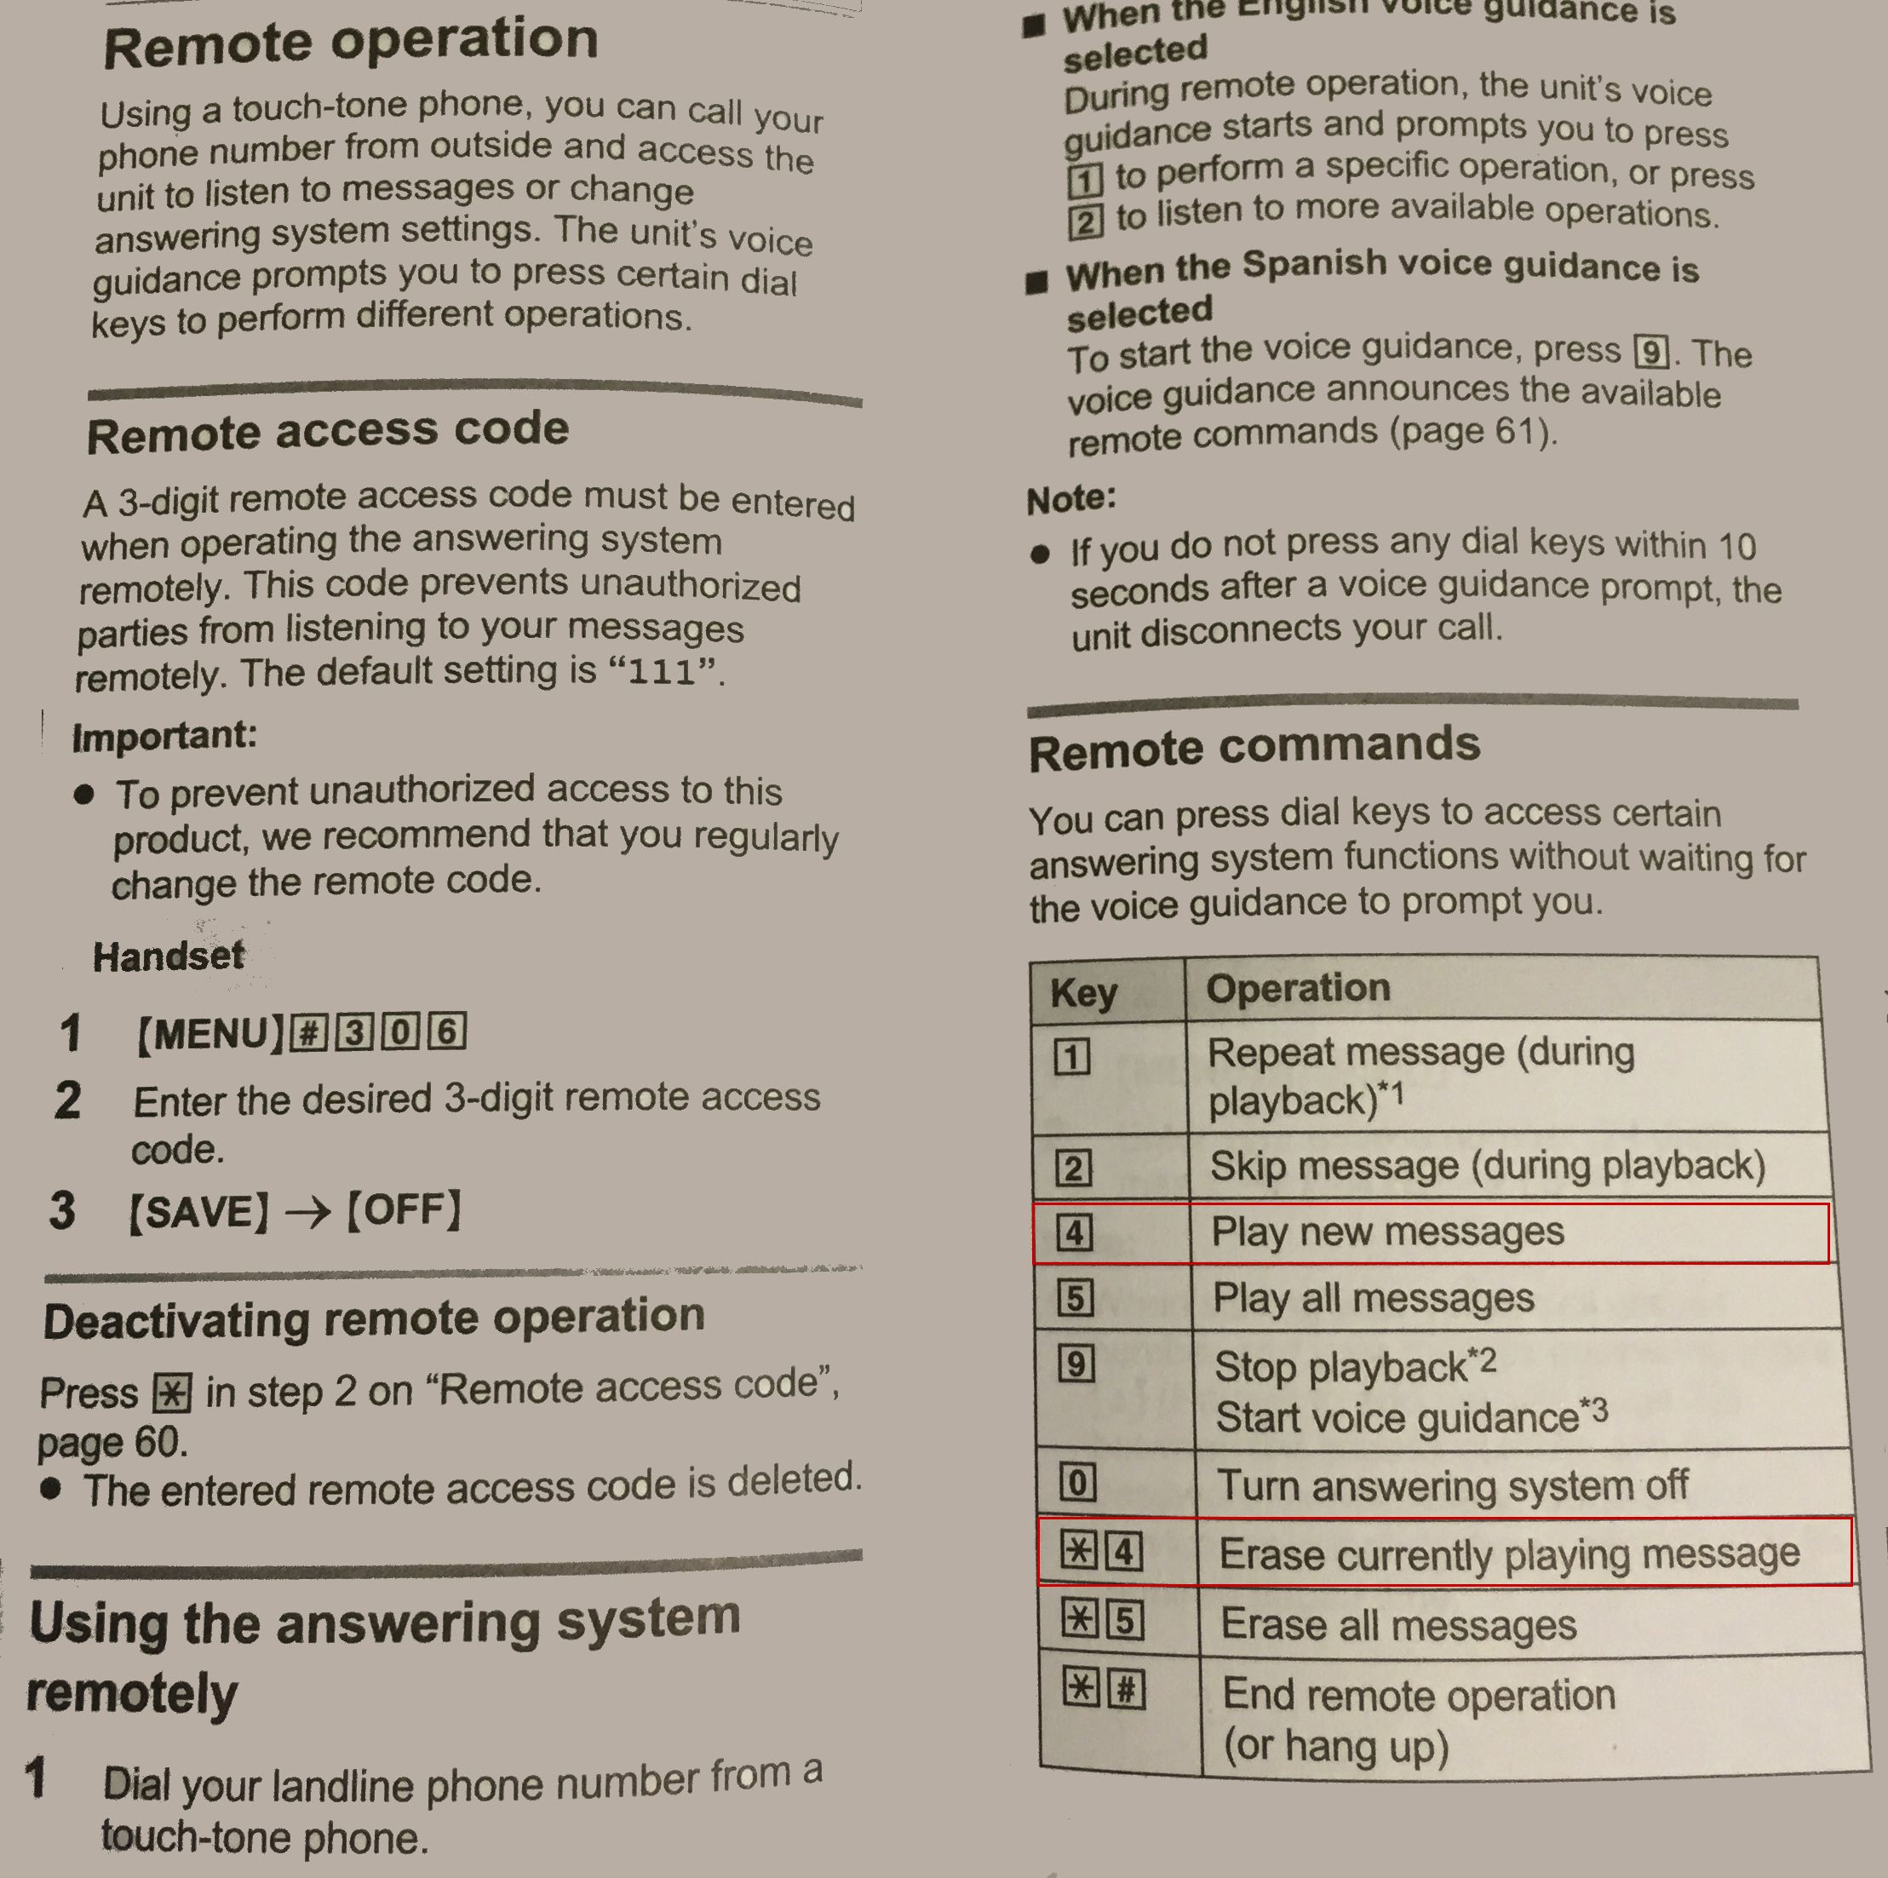

|  |  |  |  |  |
| --- | --- | --- | --- | --- |
| Monday  Monday | Tuesday  Tuesday | Wednesday  Wednesday | Thursday  Thursday | Friday  Friday |
| Saturday  Saturday | Sunday  Sunday | Formal Night  Formal Night | Bling Night  Bling Night | Board Ship  Board Ship |
| Formal Night  Formal Night | Going Home  Going Home | Makeup  Makeup | Shore Tour  Shore Tour | Shore Tour  Shore Tour |
| Monday PM  Monday PM | Tuesday PM  Tuesday PM | Wednesday PM  Wednesday PM | Thursday PM  Thursday PM | Friday PM  Friday PM |
| Saturday PM  Saturday PM | Sunday PM  Sunday PM | Formal Night  Formal Night | Hair  Hair | Pre Cruise  Pre Cruise |
| Jewelry  Jewelry | Sunday  Sunday | Red Shirt Night  Red Shirt Night | Panties  Panties | Bras  Bras |
| Tropical Night  Tropical Night | Swimming  Swimming | Swimming  Swimming | Shore Tour  Shore Tour | Shore Tour  Shore Tour |
| Cover Up  Cover Up | Cover Up  Cover Up | Swimming Backup  Swimming Backup | Slips  Slips | Meds  Meds |
| Special T-Shirt  Special T-Shirt | Western Night  Western Night | Tropical Night  Tropical Nigh | Red Shirt Night  Red Shirt Night | Bling Night  Bling Night |

|  |  |  |  |  |
| --- | --- | --- | --- | --- |
| Monday PM  Monday PM | Tuesday PM  Tuesday PM | Wednesday PM  Wednesday PM | Thursday PM  Thursday PM | Friday PM  Friday PM |
| Saturday PM  Saturday PM | Sunday PM  Sunday PM | Formal Night  Formal Night | Board Ship  Board Ship | Meds  Medså |