# Birthday Harmony Packing List

Before Leaving:

Advise Family / Police of Itinerary

Empty Perishables from Fridge

Gather Trash

Hold Mail / Put Package Sign on Door

Mail Bills / Gifts / Holiday Cards

Instructions / Key to Person Watching House

Make Bank Deposit / Get Cash

Set Timers / Lights

Turn Off A/C

Turn Off Ice Maker

Turn Off Computer / Cables / Mouse / Software

Water Plants / Open Blinds for Light

Words for Postcards / Post Card Address Labels / Stamps

For Carry On Bag:

Airline Ticket / Baggage Tags / Cruise Ticket / Cruise Passage Contract / Passport / Travel Documents / Copy of Travel Insurance

Blanket

Books

Camera / Batteries / Memory Cards / Charger

Cell Phone / Phone Numbers / Charger

Ear Plugs / Sleep Mask

Jewelry

Money / Traveler’s Checks / Credit Cards /

Excursions / Tips / Slots / Souvenirs

Reading Glasses / Contact Lenses

Rx Drugs / Excedrin / Naproxen /Aspirin / Tylenol / Airborne / Motion Sickness / Antibiotic / Rx Documentation

Snack for Trip / Emergencies

Travel Pillow

Travel Umbrella / Rain Poncho

Clothes:

Belts / Gloves / Hats / Scarves / Ties

Bras / Underwear / Slips

Dresses / Skirts – Casual / Formal / Dressy

Jackets / Coat

Pajamas / Robe / Slippers

Shirts / T-Shirts

Shoes / Boots / Snow Boots – Flip Flops /

Casual / Dress / Sneakers / Water Shoes

Shorts

Slacks / Jeans

Socks / Hose

Sweaters / Sweatshirts

Swim Suits / Beach Towel / Cover Up / Sun Hat

Toiletries:

Alcohol Wipes / Kit / Bactine Spray / Band Aids / Deep Woods Off / Suntan Lotion

Blow Dryer / Curling Iron / Clips / Hot Rollers

Hair Brush / Hair Spray

Hair Conditioner / Hair Shampoo

Kleenex / Tissue / Handkerchiefs

Lotion / Moisturizer

Makeup / Mirror

Nail Polish / Remover

Q-Tips

Razor / Shave Cream

Safety Pins / Sewing Kit

Soap

Toothbrush / Toothpaste

Miscellaneous:

Back Pack / Fanny Pack / Purses

Bed Pillow / Air Mattress / Bedding / Towels / Sleeping Bag

Binoculars

Bottled Water / Soft Drinks-6 Pack

Business Cards / Calling Cards / Insurance Card

Camp Chair

Door Decorations / Putty or Magnet or Tape

Downy Wrinkle Release / Laundry Soap

Floats / Snorkel Gear

Food - Candy / Caramels / Cheese / Cookies / White Chocolate / Crackers / Zip Bags

Groceries – Baked Goods

Hobby / Craft Project

Highlighters / Pens / Note Paper / Post It Notes / Writing Paper / Bookmarks / Playing Cards

Ice Chest

Passport Photo Copy / Birth Certificate Copy

Plastic Bags for Dirty Clothes

Power Converter Plugs

Travel Alarm

Travel Games (Cards / Scrabble / Connect 4 / Hi-Q / Dot Dot Dot / Sudoku / Crossword / Guesstures)

# Birthday Harmony Agenda

|  |  |  |  |  |  |  |
| --- | --- | --- | --- | --- | --- | --- |
| Friday, September 7 – Day Minus 1 – Mansfield to Ft. Lauderdale, Florida | | | | | | |
| 8:00 AM | Brandi Depart LAX AA 313 | | | | Record locator: ?  **Seat 9C** | |
| 8:45 AM | Linda taking Bonney to airport | | | |  | |
| 10:35 AM | Mansfield to Ft. Lauderdale  Mom Depart DFW AA 1180 | | | | Record locator: EAPAUK  Seat 29F | |
| Bra/Slip | Panties | Top | Bottom | Shoes | Jewelry / Other |
| Beige Cami | Yellow | Yellow Multi Dress |  | Multi Orange Flip Flops |  |
| 2:24 PM | Mom Arrive FLL AA 1180 | | | |  | |
| 3:00 PM? | Mom Take Shuttle to Courtyard Marriott from FLL Airport  Courtesy Phone Available Airport Phone: +1 954-359-1200  Airport shuttle service, on request, complimentary Mon-Sun: 05:00 AM - 00:00 AM | | | | Confirmation: 95313730  Record Locator: FXLNUP  400 Gulf Stream Way  Dania Beach, FL 33004  954-342-8333 | |
|  | Royal Caribbean Shore Tours  <http://www.royalcaribbean.com/beforeyouboard/shoreExcursions/downloadBrochure/excursions.php?ship=HM&date=2018-09-08&currency=USD&%3Acq_csrf_token=undefined#September-12> | | | |  | |
| 4:16 PM | Brandi Arrive MIA AA 313 | | | |  | |
| 4:45 PM? | Brandi Uber or Take Taxi to Courtyard Marriott FLL Airport | | | | 400 Gulf Stream Way  Dania Beach, FL 33004  954-342-8333 | |
| 6:30 PM | Dinner at Hotel Restaurant | | | |  | |
|  | | | | | | |
| Saturday, September 8 – Day 1 – Ft. Lauderdale, Florida | | | | | | |
| 10:30 AM | Take Shuttle from Courtyard Marriott FLL Airport to Cruise Port  Airport Phone: +1 954-359-1200  Cruise port shuttle service, on request, complimentary | | | |  | |
| 11:00 AM | Board Ship | | | | Reservation - #4894900  Harmony of the Seas  Group 4490364  Ocean View **Cabin 7652** | |
| Bra/Slip | Panties | Top | Bottom | Shoes | Jewelry / Other |
| White Cami | Black | Black and White Stripe Shirt | Black Nylon Shorts |  | 2 Red Paper Necklaces |
|  | Distribute Items | | | | Door Tags ( 4) | |
| Lanyards (6 ) | |
| Name Tags ( 6) | |
| Bookmarks (5 ) | |
| 6:00 PM | Casual Dinner – No Shorts | | | |  | |
| Bra/Slip | Panties | Top | Bottom | Shoes | Jewelry / Other |
| Navy Cami | Yellow | Red Sleeveless | Black Slacks |  |  |
|  | | | | | | |

|  |  |  |  |  |  |  |
| --- | --- | --- | --- | --- | --- | --- |
| Sunday, September 9 – Day 2 – Nassau, Bahamas | | | | | | |
| 7:00 AM | Arrive Nassau, Bahamas | | | |  | |
| 8:00 AM  5 hours | Blue Lagoon Island Stingray Encounter and Beach Day | | | | $50.00 per person | |
| Bra/Slip | Panties | Top | Bottom | Shoes | Jewelry / Other |
| Navy Cami | Yellow | Red Cowl Sleeveless Blouse | Tan Shorts |  | Black and White Necklace |
| Swimming | | | |  | |
| Bra/Slip | Panties | Top | Top | Bottom | Jewelry / Other |
|  |  | Blue Print | Blue Skirt |  |  |
| Cover Up | | | | WHAT TO BRING  • SeaPass Card  • Photo Identification  • Camera  • Cash/Credit Cards  • Sun protection  • Towel (from ship)  • Hat and Sunglasses  • Swimsuit Under Cover-up or Light Clothing  • Change of Clothes  • Sandals | |
| 'Rays' the roof with a fun and new animal experience at Blue Lagoon Island! You'll enjoy access to the beautiful lagoon beach before or after your interaction. The certified animal trainers will first teach you about the natural history of the gentle southern stingray in a fun, dockside briefing. You will then be able to safely interact with their rays on a shallow platform. Feel their silky smooth fins as they glide under your fingertips, even getting a chance to feed one if you are daring. These graceful animals are fascinating to watch and interact with! You are certain to soak up this experience and 'rays your awareness' for the protection of these beautiful creatures of the sea. Professional photo and video staff will be there to capture all your memories! At your leisure choose between two return ferries back to your ship. | | | | | |
| 2:00 PM | Depart Nassau, Bahamas | | | |  | |
| 6:00 PM | Formal Dinner #1 | | | | Meet at assigned table | |
| Bra/Slip | Panties | Top | Bottom | Shoes | Jewelry / Other |
| Black Cami | Yellow | Black Sleeveless Cowl Dress / White Elephant Scarf | | Black Patent Flip Flops | Black Weave Purse / Crystal and Turquoise Necklaces |
|  | | | | | | |
| Monday, September 10 – Day 3 - At Sea | | | | | | |
| 9:30 AM | At Sea | | | |  | |
| Bra/Slip | Panties | Top | Bottom | Shoes | Jewelry / Other |
| Red Cami | Yellow | Red Cowl Sleeveless Blouse | White Shorts |  | Red and Yellow Necklace |
| Swimming | | | |  | |
| Bra/Slip | Panties | Top | Top | Shoes | Jewelry / Other |
|  |  | Blue Print | Blue Skirt |  |  |
| Cover Up | | | | Towel | |
| 6:00 PM | Casual Dinner – No Shorts | | | | Meet at assigned table | |
| Bra/Slip | Panties | Top | Bottom | Shoes | Jewelry / Other |
| Black Cami | Black | Red Cowl Sleeveless Blouse | Gray Knit Pants |  | Red and Yellow Necklace |
|  | | | | | | |
| Tuesday, September 11 – Day 4 – Charlotte Amalie, St. Thomas | | | | | | |
| 10:00 AM | Arrive Charlotte Amalie, St. Thomas | | | |  | |
| 12:30 PM  3 hours 30 min | Magens Bay Beach Getaway - | | | | STM6 $32.00  Beach chairs, beach toys, snorkel gear available for rent. | |
| Bra/Slip | Panties | Top | Bottom | Shoes | Jewelry / Other |
|  |  | Blue Print | Blue Skirt |  |  |
| Bra/Slip | Panties | Top | Bottom | Shoes | Jewelry / Other |
| Black Cami | Yellow | Black Sleeveless T-Shirt | Tan Shorts |  |  |
| Cover Up | | | | WHAT TO BRING  • SeaPass Card  • Photo Identification  • Camera  • Cash/Credit Cards  • Sun Protection  • Towel (from Ship)  • Insect Repellent  • Hat and Sunglasses  • Swimsuit Under Cover-up or Light Clothing  • Walking Shoes | |
| Known for its signature heart shape, Magens Bay Beach is considered one of the world's most beautiful beaches. Swim in the turquoise waters and relax on the pristine sands of this picturesque beach getaway. Enjoy 2.5 hours of free time in this gorgeous paradise along the island's north coast. On your way there, enjoy panoramic views of St. Thomas from the famous Drake's Seat lookout, situated on the hillside above Magens Bay. Afterward, stop in Charlotte Amalie to enjoy some duty-free shopping or grab dinner before making your way back to the ship.  Highlights:  Magens Bay: Swim or snorkel in the gorgeous, turquoise bay on St. Thomas' north coast.  Drake's Seat: Take photos at the famous Drake's Seat Overlook, featuring stunning views of Magens Bay and the British Virgin Islands.  Charlotte Amalie: Opt for duty-free shopping, visit local attractions, or grab a bite before making your own way back to the ship. | | | | | |
| 6:00 PM | Depart Charlotte Amalie, St. Thomas | | | |  | |
| 6:00 PM | Casual Dinner – no shorts | | | | Meet at assigned table | |
| Bra/Slip | Panties | Top | Bottom | Shoes | Jewelry / Other |
| Black Cami | Yellow | Black Sleeveless T-Shirt | Spotted Skirt / Top |  |  |
|  | | | | | | |

|  |  |  |  |  |  |  |
| --- | --- | --- | --- | --- | --- | --- |
| Wednesday, September 12 – Day 5 – Philipsburg, St. Maarten | | | | | | |
| 7:00 AM | Arrive Philipsburg, St. Maarten | | | |  | |
| 10:00 AM | Buccaneer Beach Getaway | | | | SMO1 - $57.00 | |
| Bra/Slip | Panties | Top | Bottom | Shoes | Jewelry / Other |
|  |  | Turquois Multi | Black Skirt |  |  |
| Bra/Slip | Panties | Top | Bottom | Shoes | Jewelry / Other |
| Black Cami | Yellow | Black Sparkle Cowl Blouse | Gray Shorts |  | Yellow Glass Red Multi Necklace |
| Cover Up | | | | WHAT TO BRING  • SeaPass Card  • Photo Identification  • Camera  • Cash/Credit Cards  • Sun Protection  • Towel (from Ship)  • Insect Repellent  • Hat and Sunglasses  • Swimsuit Under Cover-up or Light Clothing  • Flip-Flops | |
| Relax on a beautiful white-sand beach surrounded by palm trees in the calm waters of Simpson Bay — a great place to spend your time while in St. Maarten. On your way, stop for a panoramic photo overlooking the gorgeous Simpson Bay Lagoon. At Buccaneer Beach, sip a complimentary fruit or rum punch plus enjoy a light lunch. Then spend about three hours playing in the turquoise waters or simply relaxing on the sparkling-white beach.  Highlights:  Tropical beach setting: Relax and play on a picture-perfect, palm-fringed beach along the calm turquoise waters of Simpson Bay.  Beverage and lunch included: Sip a welcome fruit or rum punch; light lunch includes burgers or chicken sandwiches.  Optional extras: For an additional charge, enjoy drinks and delicious items from the main menu at Buccaneer Beach Bar. | | | | | |
| 4:00 PM | Depart Philipsburg, St. Maarten | | | |  | |
| 6:00 PM | Casual Dinner – no shorts | | | | Meet at assigned table | |
| Bra/Slip | Panties | Top | Bottom | Shoes | Jewelry / Other |
| Black Cami | Yellow | Black Sparkle Cowl Blouse | Gray Knit Pants from Monday |  | Yellow Glass Red Multi Necklace |
|  | | | | | | |
| Thursday, September 13 – Day 6 – At Sea | | | | | | |
|  | Swimming – | | | |  | |
| Bra/Slip | Panties | Top | Bottom | Shoes | Jewelry / Other |
|  |  | Turquois Multi | Black Skirt |  |  |
| 8:30 AM |  | | | |  | |
|  | At Sea | | | |  | |
| Bra/Slip | Panties | Top | Bottom | Shoes | Jewelry / Other |
| Off White Cami | Yellow | Hot Pink Cowl Blouse | Gray Shorts | White Flip Flops | Colorful Elephant Necklace |
| 1:30 PM | Lunch at Chops Grille? | | | | $29.00 | |
| Bra/Slip | Panties | Top | Bottom | Shoes | Jewelry / Other |
| Off White Cami | Yellow | Blue and White Crinkle Dress | | White Flip Flops | 2 Red Glass Multi Necklace |
|  |  | | | |  | |
| 6:00 PM | Causal Dinner – no shorts | | | | Meet at assigned table | |
| Bra/Slip | Panties | Top | Bottom | Shoes | Jewelry / Other |
| Off White Cami | Yellow | Blue and White Crinkle Dress | | White Flip Flops | 2 Red Glass Multi Necklace |
|  | | | | | | |
| Friday, September 14 – Day 7 – At Sea | | | | | | |
|  | Swimming | | | |  | |
| Bra/Slip | Panties | Top | Bottom | Shoes | Jewelry / Other |
|  |  | Turquois Multi | Black Skirt |  |  |
| 9:30 AM | At Sea | | | |  | |
| Bra/Slip | Panties | Top | Bottom | Shoes | Jewelry / Other |
| Off White Cami | Yellow | Ivory Short Sleeve Blouse | Black Slacks |  | 2 Red Glass Multi Necklace |
|  |  | | | |  | |
|  |  | | | |  | |
| 6:00 PM | Formal Dinner #2 | | | | Meet at assigned table | |
| Bra/Slip | Panties | Top | Bottom | Shoes | Jewelry / Other |
| Black Under Blouse | Yellow | Ivory Short Sleeve Blouse | Black Knit Slacks |  | 2 Red Glass Multi Necklace |
|  | | | | | | |
| Saturday, September, 15 – Day 8 – Ft. Lauderdale, Florida | | | | | | |
| 6:15 AM | Depart Ft. Lauderdale, Florida | | | |  | |
| 9:30 AM |  | | | |  | |
| Bra/Slip | Panties | Top | Bottom | Shoes | Jewelry / Other |
| Black Cami | Yellow | Aqua Cowl Blouse | Black Nylon Shorts |  | Black and White Necklace |
|  | Brandi Board Transfer Shuttle to Miami | | | |  | |
| After 1:30 PM | Depart Miami, Florida | | | | Record locator: **?**  **Seat 9C** | |
| 3:15 PM | Depart FLL on AA 1180 | | | | Record locator: **JRSWGB**  **Seat 13F** | |
| 5:30 PM | Arrive DFW on AA 1180 | | | |  | |
| 6:00 PM | Take Uber home | | | |  | |
| After 1:30 PM | Depart Miami, Florida | | | |  | |
|  | | | | | | |

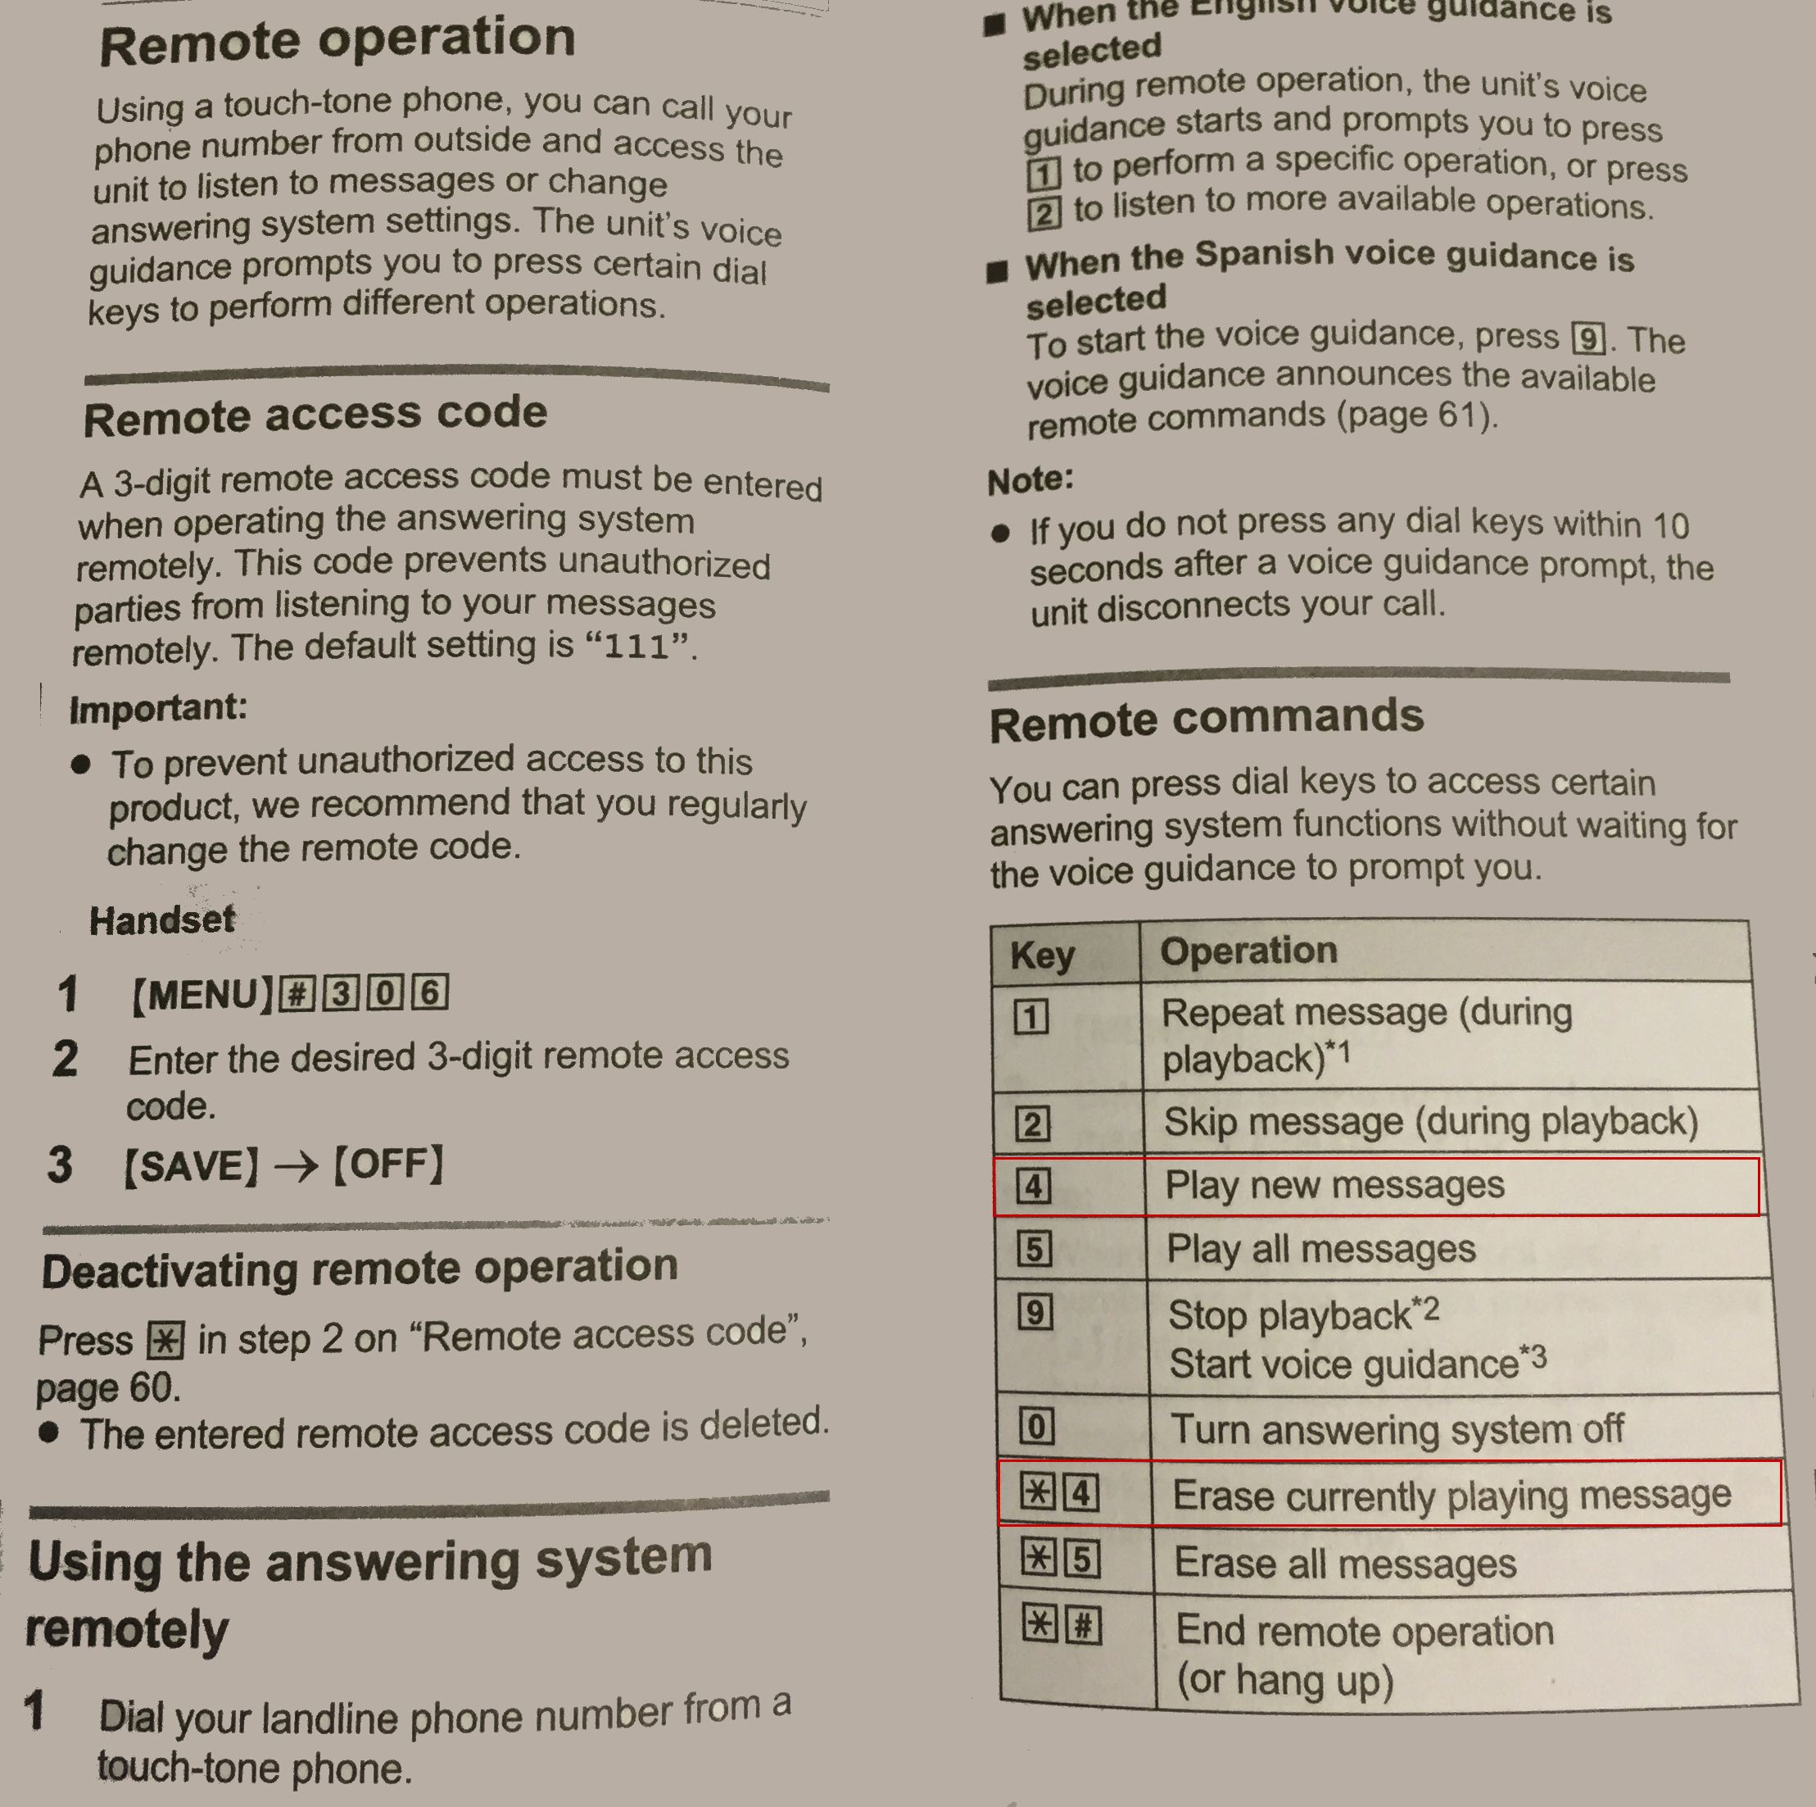

|  |  |  |  |  |
| --- | --- | --- | --- | --- |
| Saturday  Saturday | Tuesday  Tuesday | Wednesday  Wednesday | Thursday  Thursday | Friday  Friday |
| Saturday  Saturday | Sunday  Sunday | Formal Night  Formal Night | Bling Night  Bling Night | Board Ship  Board Ship |
| Formal Night  Formal Night | Going Home  Going Home | Makeup  Makeup | Shore Tour  Shore Tour | Shore Tour  Shore Tour |
| Monday PM  Monday PM | Tuesday PM  Tuesday PM | Wednesday  Wednesday | Thursday PM  Thursday PM | Friday PM  Friday PM |
| Saturday PM  Saturday PM | Sunday PM  Sunday PM | Formal Night  Formal Night | Hair  Hair | Pre Cruise  Pre Cruise |
| Jewelry  Jewelry | Sunday  Sunday | Red Shirt Night  Red Shirt Night | Panties  Panties | Bras  Bras |
| Tropical Night  Tropical Night | Swimming  Swimming | Swimming  Swimming | Shore Tour  Shore Tour | Shore Tour  Shore Tour |
| Cover Up  Cover Up | Cover Up  Cover Up | Swimming Backup  Swimming Backup | Slips  Slips | Meds  Meds |
| Special T-Shirt  Special T-Shirt | Western Night  Western Night | Tropical Night  Tropical Night | Red Shirt Night  Red Shirt Night | Bling Night  Bling Night |

|  |  |  |  |  |
| --- | --- | --- | --- | --- |
| Monday PM  Monday PM | Tuesday PM  Tuesday PM | Wednesday PM  Wednesday PM | Thursday PM  Thursday PM | Friday PM  Friday PM |
| Saturday PM  Saturday PM | Sunday PM  Sunday PM | Formal Night  Formal Night | Board Ship  Board Ship | Meds  Meds |