# Hawaiian Whales Ruby Princess Cruise Packing List

Before Leaving:

Advise Family / Police of Itinerary

Cell Phone / Phone Numbers / Charger

Empty Perishables from Fridge

Gather Trash

Hold Mail / Put Package Sign on Door

Mail Bills / Gifts / Holiday Cards

Instructions / Key to Person Watching House

Make Bank Deposit / Get Cash

Set Timers / Lights

Turn Off A/C

Turn Off Ice Maker

Turn Off Computer / Cables / Mouse / Software

Water Plants / Open Blinds for Light

Words for Postcards / Post Card Address Labels / Stamps

For Carry On Bag:

Airline Ticket / Baggage Tags / Cruise Ticket / Cruise Passage Contract / Passport / Travel Documents / Copy of Travel Insurance

Blanket

Books

Camera / Batteries / Memory Cards / Charger

Ear Plugs / Sleep Mask

Jewelry

Money / Traveler’s Checks / Credit Cards /

Excursions / Tips / Slots / Souvenirs

Reading Glasses / Contact Lenses

Rx Drugs / Excedrin / Naproxen /Aspirin / Tylenol / Airborne / Motion Sickness / Antibiotic / Rx Documentation

Snack for Trip / Emergencies

Travel Pillow

Travel Umbrella / Rain Poncho

Clothes:

Belts / Gloves / Hats / Scarves / Ties

Bras / Underwear / Slips

Dresses / Skirts – Casual / Formal / Dressy

Jackets / Coat

Pajamas / Robe / Slippers

Shirts / T-Shirts

Shoes / Boots / Snow Boots – Flip Flops /

Casual / Dress / Sneakers / Water Shoes

Shorts

Slacks / Jeans

Socks / Hose

Sweaters / Sweatshirts

Swim Suits / Beach Towel / Cover Up / Sun Hat

Toiletries:

Alcohol Wipes / Kit / Bactine Spray / Band Aids / Deep Woods Off / Suntan Lotion

Blow Dryer / Curling Iron / Clips / Hot Rollers

Hair Brush / Hair Spray

Hair Conditioner / Hair Shampoo

Kleenex / Tissue / Handkerchiefs

Lotion / Moisturizer

Makeup / Mirror

Nail Polish / Remover

Q-Tips

Razor / Shave Cream

Safety Pins / Sewing Kit

Soap

Toothbrush / Toothpaste

Miscellaneous:

Back Pack / Fanny Pack / Purses

Back Scratcher

Bed Pillow / Air Mattress / Bedding / Towels / Sleeping Bag

Binoculars

Bottled Water / Soft Drinks-6 Pack

Business Cards / Calling Cards / Insurance Card

Camp Chair

Door Decorations / Putty or Magnet or Tape

Downy Wrinkle Release / Laundry Soap

Floats / Snorkel Gear

Food - Candy / Caramels / Cheese / Cookies / White Chocolate / Crackers / Zip Bags

Groceries – Baked Goods

Hobby / Craft Project

Highlighters / Pens / Note Paper / Post It Notes / Writing Paper / Bookmarks / Playing Cards

Ice Chest

Passport Photo Copy / Birth Certificate Copy

Plastic Bags for Dirty Clothes

Power Converter Plugs

Travel Alarm

Travel Games (Cards / Scrabble / Connect 4 / Hi-Q / Dot Dot Dot / Sudoku / Crossword / Guesstures)

# Hawaiian Whales Ruby Princess Cruise Itinerary

|  |  |  |  |  |  |  |
| --- | --- | --- | --- | --- | --- | --- |
|  | | | | | | |
| Thursday, March 21 – Day Minus 3 – Mansfield to Los Angeles | | | | | | |
|  |  | | | |  | |
| 9:30 AM |  | | | |  | |
| Bra/Slip | Panties | Top | Bottom | Shoes | Jewelry / Other |
|  |  |  |  |  |  |
|  | Hand towel from Los Angeles | | | |  | |
|  |  | | | |  | |
| 6:00 PM | Dinner | | | |  | |
| Bra/Slip | Panties | Top | Bottom | Shoes | Jewelry / Other |
|  |  |  |  |  |  |
|  | | | | | | |
| Friday, March 22 – Day Minus 2 – Los Angeles with Brandi | | | | | | |
|  |  | | | |  | |
| 9:30 AM |  | | | |  | |
| Bra/Slip | Panties | Top | Bottom | Shoes | Jewelry / Other |
|  |  |  |  |  |  |
|  |  | | | |  | |
| 6:00 PM | Dinner | | | |  | |
| Bra/Slip | Panties | Top | Bottom | Shoes | Jewelry / Other |
|  |  |  |  |  |  |
|  | | | | | | |
| Saturday, March 23 – Day Minus 1 – From Brandi to Hotel | | | | | | |
|  |  | | | |  | |
| 9:30 AM |  | | | |  | |
| Bra/Slip | Panties | Top | Bottom | Shoes | Jewelry / Other |
|  |  |  |  |  |  |
|  |  | | | |  | |
| 6:00 PM | Dinner | | | |  | |
| Bra/Slip | Panties | Top | Bottom | Shoes | Jewelry / Other |
|  |  |  |  |  |  |
|  | | | | | | |
| *** Sunday, March 24 – Day 0 Transfer From Hotel to Ruby Princess *** | | | | | | |
|  |  | | | |  | |
| 1:00 PM – 3:00 PM | Board Ship in San Pedro | | | | Reservation – **#VC3J9R** **Ruby Princess Stateroom: R744 / IE**  **Group: TPM R914** | |
| Bra/Slip | Panties | Top | Bottom | Shoes | Jewelry / Other |
|  |  |  |  |  |  |
|  | Distribute Items | | | | Door Tags ( ) | |
| Lanyards ( ) | |
| Name Tags ( ) | |
| Bookmarks ( ) | |
| 4:00 PM | Depart San Pedro, California | | | |  | |
| 6:00 PM | Sunday Casual Dinner – no shorts | | | | Meet at assigned table | |
| Bra/Slip | Panties | Top | Bottom | Shoes | Jewelry / Other |
|  |  |  |  |  |  |
|  | | | | | | |
| Monday, March 25 – Day 1 – At Sea | | | | | | |
|  | Swimming | | | |  | |
|  |  | | | |  | |
| Bra/Slip | Panties | Top | Bottom | Shoes | Jewelry / Other |
|  |  | Blue Print | Blue Skirt |  |  |
|  |  | | | |  | |
| 9:30 AM |  | | | |  | |
| Bra/Slip | Panties | Top | Bottom | Shoes | Jewelry / Other |
|  |  |  |  |  |  |
|  |  | | | |  | |
| 6:00 PM | Monday Formal Dinner #1 | | | | Meet at assigned table **Tiaras and Ties**– Dress up with tiaras, boas, ties, etc. | |
| Bra/Slip | Panties | Top | Bottom | Shoes | Jewelry / Other |
|  |  |  |  |  |  |
|  | | | | | | |
| Tuesday, March 26 – Day 2 – At Sea | | | | | | |
|  |  | | | |  | |
| 9:30 AM |  | | | |  | |
| Bra/Slip | Panties | Top | Bottom | Shoes | Jewelry / Other |
|  |  |  |  |  |  |
|  | Start Photo Scavenger Hunt | | | | Pass out flyer | |
| 6:00 PM | Tuesday Casual Dinner – no shorts | | | | Meet at assigned table | |
| Bra/Slip | Panties | Top | Bottom | Shoes | Jewelry / Other |
|  |  |  |  |  |  |
|  | | | | | | |
| Wednesday, March 27 – Day 3 – At Sea | | | | | | |
|  |  | | | |  | |
| 9:30 AM |  | | | |  | |
| Bra/Slip | Panties | Top | Bottom | Shoes | Jewelry / Other |
| Off White Cami | Yellow | Hot Pink Cowl Blouse | Gray Shorts |  | Black Glass Necklace |
|  |  | | | |  | |
| 6:00 PM | Wednesday Casual Dinner – no shorts | | | | Meet at assigned table | |
| Bra/Slip | Panties | Top | Bottom | Shoes | Jewelry / Other |
|  |  |  |  |  |  |
|  | | | | | | |
| Thursday, March 28 - Day 4 – At Sea | | | | | | |
|  |  | | | |  | |
| 9:30 AM |  | | | |  | |
| Bra/Slip | Panties | Top | Bottom | Shoes | Jewelry / Other |
|  |  |  |  |  |  |
|  |  | | | |  | |
| 6:00 PM | Thursday Casual Dinner – no shorts | | | | Meet at assigned table | |
| Bra/Slip | Panties | Top | Bottom | Shoes | Jewelry / Other |
|  |  |  |  |  |  |
|  | | | | | | |
| Friday, March 29 – Day 5 – Hilo, Hawaii | | | | | | |
| 9:00 AM | Arrive Hilo, Hawaii | | | |  | |
|  |  | | | |  | |
|  | Swimming – Shore Tour | | | |  | |
|  |  | | | |  | |
| Bra/Slip | Panties | Top | Bottom | Shoes | Jewelry / Other |
|  |  | Black | Black Skirt |  |  |
| 9:30 AM |  | | | |  | |
| Bra/Slip | Panties | Top | Bottom | Shoes | Jewelry / Other |
|  |  |  |  |  |  |
|  | Hand towel from Hilo | | | |  | |
|  | Pass out Eye Pads | | | |  | |
| 6:00 PM | Depart Hilo, Hawaii | | | |  | |
| 6:00 PM | Friday Casual Dinner – no shorts | | | | Meet at assigned table | |
| Bra/Slip | Panties | Top | Bottom | Shoes | Jewelry / Other |
|  |  |  |  |  |  |
|  | | | | | | |
| Saturday, March 30 – Day 6 – Honolulu, Oahu | | | | | | |
| 7:00 AM | Arrive Honolulu, Oahu | | | |  | |
|  |  | | | |  | |
| 9:30 AM |  | | | |  | |
| Bra/Slip | Panties | Top | Bottom | Shoes | Jewelry / Other |
|  |  |  |  |  |  |
|  | Hand towel from Honolulu | | | |  | |
|  |  | | | |  | |
|  |  | | | |  | |
| 6:00 PM | Saturday Casual Dinner – no shorts | | | | Meet at assigned table **Tropical Attire**– Wear something tropical | |
| Bra/Slip | Panties | Top | Bottom | Shoes | Jewelry / Other |
|  |  |  |  |  |  |
| 11:00 PM | Depart Honolulu, Oahu | | | |  | |
|  | | | | | | |
| Sunday, March 31 – Day 7 – Nawiliwili, Kauai | | | | | | |
| 8:00 AM | Arrive Nawiliwili, Kauai | | | |  | |
|  |  | | | |  | |
| 9:30 AM |  | | | |  | |
| Bra/Slip | Panties | Top | Bottom | Shoes | Jewelry / Other |
|  |  |  |  |  |  |
|  | Hand towel from Nawiliwili | | | |  | |
|  |  | | | |  | |
| 5:00 PM | Depart Nawiliwili, Kauai | | | |  | |
| 6:00 PM | Sunday Casual Dinner – no shorts | | | | Meet at assigned table | |
| Bra/Slip | Panties | Top | Bottom | Shoes | Jewelry / Other |
|  |  |  |  |  |  |
|  | | | | | | |
| Monday, April 1 – Day 8 – Lahaina, Maui | | | | | | |
| 7:00 AM | Arrive Lahaina, Maui (tender required) | | | |  | |
|  |  | | | |  | |
| 9:30 AM |  | | | |  | |
| Bra/Slip | Panties | Top | Bottom | Shoes | Jewelry / Other |
|  |  |  |  |  |  |
|  | Hand towel from Lahaina | | | |  | |
|  |  | | | |  | |
| 6:00 PM | Depart Lahaina, Maui | | | |  | |
| 6:00 PM | Monday Casual Dinner – no shorts | | | | Meet at assigned table | |
| Bra/Slip | Panties | Top | Bottom | Shoes | Jewelry / Other |
|  |  |  |  |  |  |
|  | | | | | | |
| Tuesday, April 2 – Day 9 – At Sea | | | | | | |
|  |  | | | |  | |
|  | Swimming – Backup | | | |  | |
|  |  | | | |  | |
| Bra/Slip | Panties | Top | Bottom | Shoes | Jewelry / Other |
|  |  | White Print | Black Skirt |  |  |
| 9:30 AM |  | | | |  | |
| Bra/Slip | Panties | Top | Bottom | Shoes | Jewelry / Other |
|  |  |  |  |  |  |
|  |  | | | |  | |
| 6:00 PM | Tuesday Formal Dinner #2 | | | | Meet at assigned table | |
| Bra/Slip | Panties | Top | Bottom | Shoes | Jewelry / Other |
|  |  |  |  |  |  |
|  | | | | | | |
| Wednesday, April 3 – Day 10 – At Sea | | | | | | |
|  |  | | | |  | |
| 9:30 AM |  | | | |  | |
| Bra/Slip | Panties | Top | Bottom | Shoes | Jewelry / Other |
|  |  |  |  |  |  |
|  |  | | | |  | |
| 6:00 PM | Wednesday Casual Dinner – no shorts | | | | Meet at assigned table **Western Night** – Wear something western | |
| Bra/Slip | Panties | Top | Bottom | Shoes | Jewelry / Other |
|  |  |  |  |  |  |
|  | | | | | | |
|  | | | | | | |
| Thursday, April 4 – Day 11 – At Sea | | | | | | |
|  |  | | | |  | |
| 9:30 AM |  | | | |  | |
| Bra/Slip | Panties | Top | Bottom | Shoes | Jewelry / Other |
|  |  |  |  |  |  |
|  |  | | | |  | |
| 6:00 PM | Thursday Casual Dinner – no shorts | | | | Meet at assigned table | |
| Bra/Slip | Panties | Top | Bottom | Shoes | Jewelry / Other |
|  |  |  |  |  |  |
|  | | | | | | |
| Friday, April 5 – Day 12 – At Sea | | | | | | |
|  |  | | | |  | |
| 9:30 AM |  | | | |  | |
| Bra/Slip | Panties | Top | Bottom | Shoes | Jewelry / Other |
|  |  |  |  |  |  |
|  |  | | | |  | |
| 6:00 PM | Friday Casual Dinner – no shorts | | | | Meet at assigned table **Wear Red Night** – Wear something red | |
| Bra/Slip | Panties | Top | Bottom | Shoes | Jewelry / Other |
|  |  |  |  |  |  |
|  | | | | | | |
| Saturday, April 6 – Day 13 – At Sea | | | | | | |
|  |  | | | |  | |
| 9:30 AM |  | | | |  | |
| Bra/Slip | Panties | Top | Bottom | Shoes | Jewelry / Other |
|  |  |  |  |  |  |
|  |  | | | |  | |
| 6:00 PM | Saturday Formal Dinner #3 | | | | Meet at assigned table | |
| Bra/Slip | Panties | Top | Bottom | Shoes | Jewelry / Other |
|  |  |  |  |  |  |
|  | | | | | | |
| Sunday, April 7 – Day 14 – Ensenada, Mexico | | | | | | |
| 8:00 AM | Arrive Ensenada, Mexico | | | |  | |
|  |  | | | |  | |
| 9:30 AM |  | | | |  | |
| Bra/Slip | Panties | Top | Bottom | Shoes | Jewelry / Other |
|  |  |  |  |  |  |
|  | Hand towel from Ensenada | | | |  | |
|  |  | | | |  | |
| 5:00 PM | Depart Ensenada, Meico | | | |  | |
| 6:00 PM | Sunday Casual Dinner – no shorts | | | | Meet at assigned table | |
| Bra/Slip | Panties | Top | Bottom | Shoes | Jewelry / Other |
|  |  |  |  |  |  |
| 11:00 PM | Put luggage out in hallway. Be sure not to pack what you are wearing to disembark. Do not pack your passport. | | | |  | |
|  | | | | | | |
| Monday, April 8 – Day 15 – Los Angeles, California to Mansfield | | | | | | |
|  |  | | | |  | |
| 9:30 AM |  | | | |  | |
| Bra/Slip | Panties | Top | Bottom | Shoes | Jewelry / Other |
|  |  |  |  |  |  |
|  | Hand towel from | | | |  | |
|  |  | | | |  | |
| 6:00 PM | Monday Casual Dinner – no shorts | | | | Meet at assigned table | |
| Bra/Slip | Panties | Top | Bottom | Shoes | Jewelry / Other |
|  |  |  |  |  |  |
|  | | | | | | |

|  |  |  |  |  |  |  |
| --- | --- | --- | --- | --- | --- | --- |
|  |  | | | |  | |
| 9:30 AM |  | | | |  | |
| Bra/Slip | Panties | Top | Bottom | Shoes | Jewelry / Other |
|  |  |  |  |  |  |
|  | Hand towel from | | | |  | |
|  |  | | | |  | |
| Lunch | Cover Up | | | |  | |
| Bra/Slip | Panties | Top | Bottom | Shoes | Jewelry / Other |
|  |  |  |  |  |  |
|  | | | | | | |

|  |  |  |  |  |  |  |
| --- | --- | --- | --- | --- | --- | --- |
|  | Swimming | | | |  | |
|  |  | | | |  | |
| Bra/Slip | Panties | Top | Bottom | Shoes | Jewelry / Other |
|  |  |  |  |  |  |
|  | Hand towel from | | | |  | |
|  |  | | | |  | |
|  | Dinner | | | |  | |
| Bra/Slip | Panties | Top | Bottom | Shoes | Jewelry / Other |
|  |  |  |  |  |  |
|  | | | | | | |

**Home Answering Machine**

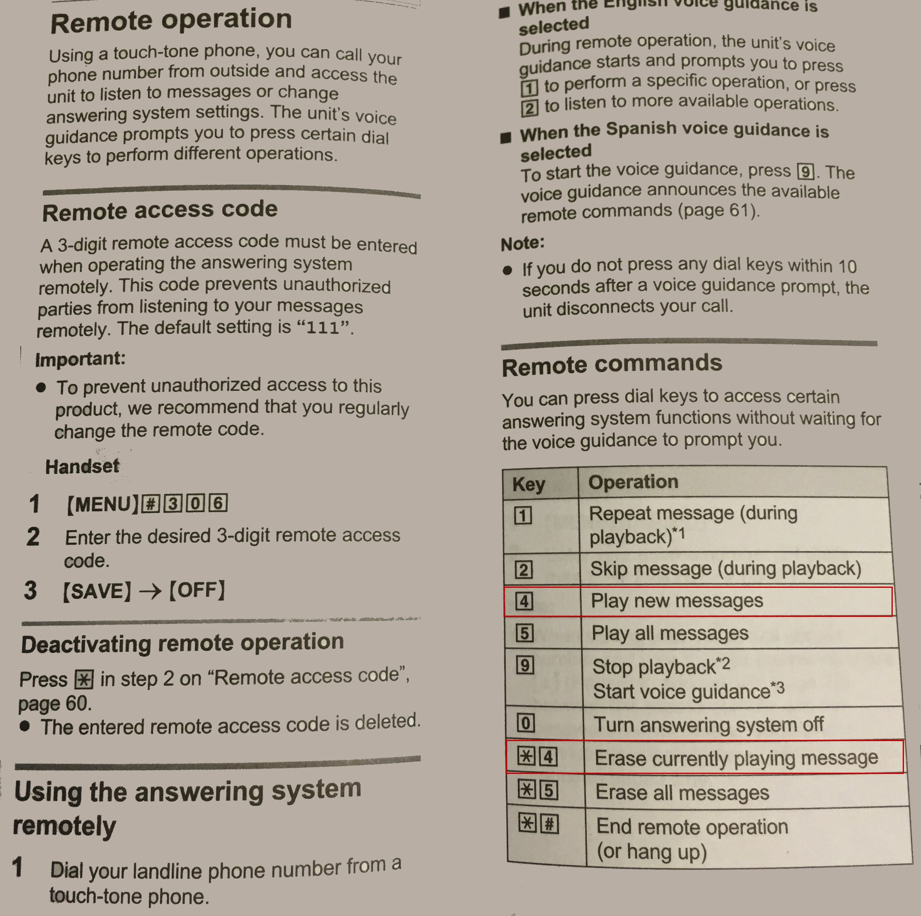

|  |  |  |  |  |
| --- | --- | --- | --- | --- |
| Monday  Monday | Tuesday  Tuesday | Wednesday  Wednesday | Thursday  Thursday | Friday  Friday |
| Saturday  Saturday | Sunday  Sunday | Formal Night  Formal Night | Bling Night  Bling Night | Board Ship  Board Ship |
| Formal Night  Formal Night | Going Home  Going Home | Makeup  Makeup | Shore Tour  Shore Tour | Shore Tour  Shore Tour |
| Monday PM  Monday PM | Tuesday PM  Tuesday PM | Wednesday PM  Wednesday PM | Thursday PM  Thursday PM | Friday PM  Friday PM |
| Saturday PM  Saturday PM | Sunday PM  Sunday PM | Formal Night  Formal Night | Hair  Hair | Pre Cruise  Pre Cruise |
| Jewelry  Jewelry | Sunday  Sunday | Red Shirt Night  Red Shirt Night | Panties  Panties | Bras  Bras |
| Tropical Night  Tropical Night | Swimming  Swimming | Swimming  Swimming | Shore Tour  Shore Tour | Shore Tour  Shore Tour |
| Cover Up  Cover Up | Cover Up  Cover Up | Swimming Backup  Swimming Backup | Slips  Slips | Meds  Meds |
| Special T-Shirt  Special T-Shirt | Western Night  Western Night | Tropical Night  Tropical Nigh | Red Shirt Night  Red Shirt Night | Bling Night  Bling Night |

|  |  |  |  |  |
| --- | --- | --- | --- | --- |
| Monday PM  Monday PM | Tuesday PM  Tuesday PM | Wednesday PM  Wednesday PM | Thursday PM  Thursday PM | Friday PM  Friday PM |
| Saturday PM  Saturday PM | Sunday PM  Sunday PM | Formal Night  Formal Night | Board Ship  Board Ship | Meds  Medså |